**Exporting Files**

# B. Charles Sutton W1MCP, Jim Hargrave W5IFP and Aki Yoshida JA1NLX

## 1.0 GENERAL

From the Logger 32 Main menu, select the Tools | Export Files option, then choose QSL, eQSL, LOTW or DXCC.

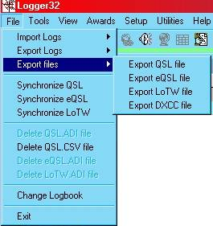

EF_1

The Export records dialog box will open. Select the appropriate operator(s) you wish to export QSO records for, or choose "All Operators". Logger32 will allow you to select more than one operator.

Export QSL file

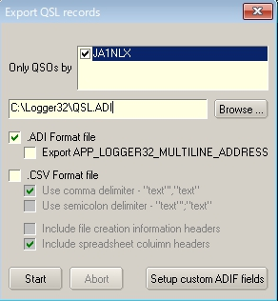

new EF_2

Export LoTW file

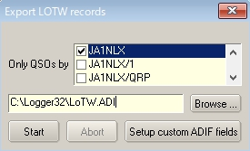

EF_2A

With the exception of DXCC files, you have the option to export an ADIF or CSV file. You may also choose a CSV file with no header record. The header record contains the ADIF field names.

Select the <**Start**> button and you will be prompted for the filename you wish to use. You can choose an existing file (doing this will overwrite all data in that file), or you can create a new file.

**Note**: Once you have made a file export, Logger32 will remember the last filename/path used. This will facilitate the use of third party software for processing the QSL actions

## 2.0 FLAG OPTIONS

For QSL, eQSL and LoTW files, once your QSO records have been exported, for you will be prompted for the QSL Flag options. The action taken depends on the type of export you chose.

**Note**: Only QSO records with the appropriate flag set will be exported. To see if a particular record is flagged, right-click on the record in the Logbook. You will see all three types listed, if there is a check mark before the file type, it is flagged for export.

### 2.1 eQSL records

If you choose yes to have these records flagged as having been sent, Logger32 will remove the export flag from all the records that were successfully exported.

### 2.2 QSL records

If you choose yes to have these records flagged as having been sent, Logger32 will:

* + Remove ~~Rremove~~ the export flag from all the records that were successfully exported;
  + Set the QSL_Sent field's flag to Y; and,
  + Add the current date to the QSLSDATE field.

### 2.3 LOTW records

If you choose yes to have these records flagged as having been sent, Logger32 will remove the export flag from all the records that were successfully exported.

### 2.4 CSV Records

User can select exported file type, ADIF file or CSV file in Export QSL file. See EF_2.

The CSV file will export two QSO dates for user discretion in QSL printing:

* + QSO_DATE field (in YYYMMDD format) which meets the ADIF specification, and
  + APP_LOGGER32_QSO_DATE in user-defined date format.

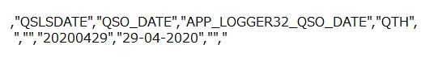

New EF_3

## 3.0 ADIF COUNTRY FIELD

Changes to the Country field in L32 version 3.x and up: Prior to the adoption of ADIF version 2, when you asked Logger32 to export the full country name, Logger32 would add an additional field named.

APP_LOGGER32_COUNTRY. ADIF version 2 now allows for a full country name field, "COUNTRY", and Logger32 will now export the full country name into that field. Please be aware that if you have other software, such as a log printing program, that is expecting to find the APP_LOGGER32_COUNTRY field, you will need to change it to COUNTRY.

Changes to the CNTY field in L32 version 3.x and up: Logger32 allows the user considerable flexibility in setup/usage of the Primary/Secondary Admin Subdivisions. For ADIF 2.x compatibility, ADIF export/import of the CNTY field will apply to countries that have ADIF defined Secondary Admin Subdivisions. Countries that have no ADIF defined Secondary Admin Subdivisions will be exported/Imported as APP_LOGGER32_CNTY.

Changes to the CNTY field in L32 version 3.x and up: STATE fields that are defined by ADIF (Primary Admin Subdivision) are exported/imported as <STATE:x> others are exported/imported as APP_LOGGER32_STATE:x>

## 4.0 ADIF MODE AND SUBMODE FIELDS

When it exports, mode and submode are exported like this,

~~a) if mode is ADIF MODE then ADIF MODE is written as <MODE>.~~

<BAND:3>15M <CALL:4>K4CY <CONT:2>NA <CQZ:1>5 <DXCC:3>291 <FREQ:9>21.140000 <ITUZ:1>8 <MODE:4>MFSK <SUBMODE:3>FT4 <OPERATOR:6>JA1NLX <PFX:2>K4 <APP_LOGGER32_eQSL:1>Y <APP_LOGGER32_LoTW:1>Y <QSO_DATE:8:D>20200325 <TIME_ON:6>000752 <RST_RCVD:3>599 <RST_SENT:3>599 <TIME_OFF:6>000752 <TX_PWR:3>100 <APP_LOGGER32_QSO_NUMBER:1>1 <FREQ_RX:9>21.140000 <EOR>

<BAND:3>15M <CALL:4>K4CY <CONT:2>NA <CQZ:1>5 <DXCC:3>291 <FREQ:9>21.074000 <ITUZ:1>8 <MODE:3>FT8 <OPERATOR:6>JA1NLX <PFX:2>K4 <APP_LOGGER32_eQSL:1>Y <APP_LOGGER32_LoTW:1>Y <QSO_DATE:8:D>20200325 <TIME_ON:6>000813 <RST_RCVD:3>599 <RST_SENT:3>599 <TIME_OFF:6>000813 <TX_PWR:3>100 <APP_LOGGER32_QSO_NUMBER:1>2 <FREQ_RX:9>21.074000 <EOR>

<BAND:3>40M <CALL:4>K4CY <CONT:2>NA <CQZ:1>5 <DXCC:3>291 <FREQ:8>7.010000 <ITUZ:1>8 <MODE:2>CW <OPERATOR:6>JA1NLX <PFX:2>K4 <APP_LOGGER32_eQSL:1>Y <APP_LOGGER32_LoTW:1>Y <QSO_DATE:8:D>20200429 <TIME_ON:6>230202 <RST_RCVD:3>599 <RST_SENT:3>599 <TIME_OFF:6>230202 <TX_PWR:3>100 <APP_LOGGER32_QSO_NUMBER:1>3 <FREQ_RX:8>7.010000 <EOR>

<BAND:3>20M <CALL:4>K4CY <CONT:2>NA <CQZ:1>5 <DXCC:3>291 <FREQ:9>14.070000 <ITUZ:1>8 <MODE:3>PSK <SUBMODE:5>PSK31 <OPERATOR:6>JA1NLX <PFX:2>K4 <APP_LOGGER32_eQSL:1>Y <APP_LOGGER32_LoTW:1>Y <QSO_DATE:8:D>20200429 <TIME_ON:6>230307 <RST_RCVD:3>599 <RST_SENT:3>599 <TIME_OFF:6>230307 <TX_PWR:3>100 <APP_LOGGER32_QSO_NUMBER:1>4 <FREQ_RX:9>14.070000 <EOR>

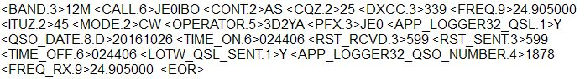

remove EF_4

~~b) If mode is ADIF SUBMODE then corresponding ADIF MODE is written as <MODE> and ADIF SUBMODE is written as <SUBMODE>~~

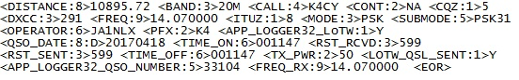

remove EF_5

**~~Note~~**~~: Currently, eQSL does not sot support SUBMODE. eQSL exports (both the ADIF export and the eQSL dump file for the N2AMG gateway) put MODE/SUBMODE back in the original format.~~

## 5.0 Setup custom ADIF fields

User can setup custom ADIF fields in exporting QSL file and LoTW file as in exporting logs. Click “Setup custom ADIF fields” button. See EF_2 or EF_2A above. Details are explained in the section “Exporting Logs”.